Design Report
for
ConRes System - 100717312

Version 1.1
Table of Contents
Table of Contents ii
Revision History ii
1. System Architecture 1
1.1 Structural View 1
1.2 Behavioural view 2
2. Code and Interface 3
2.1 Code Snippet for Thread Management 3
2.2 Code Snippet for Safe Access to Shared Resources 4
2.3 Code Snippet for Data Structure 4
3. Reflections on Design and Implementation 5
3.1 Knowledge and Skills 5
3.2 Challenges and Motivations 5

Revision History
Name | Date | Reason For Changes | Version
100717312 | 18/03/2026 | First Issue | 1.0
100717312 | 22/03/2026 | Fix problems and polish document | 1.1

System Architecture

Structural View
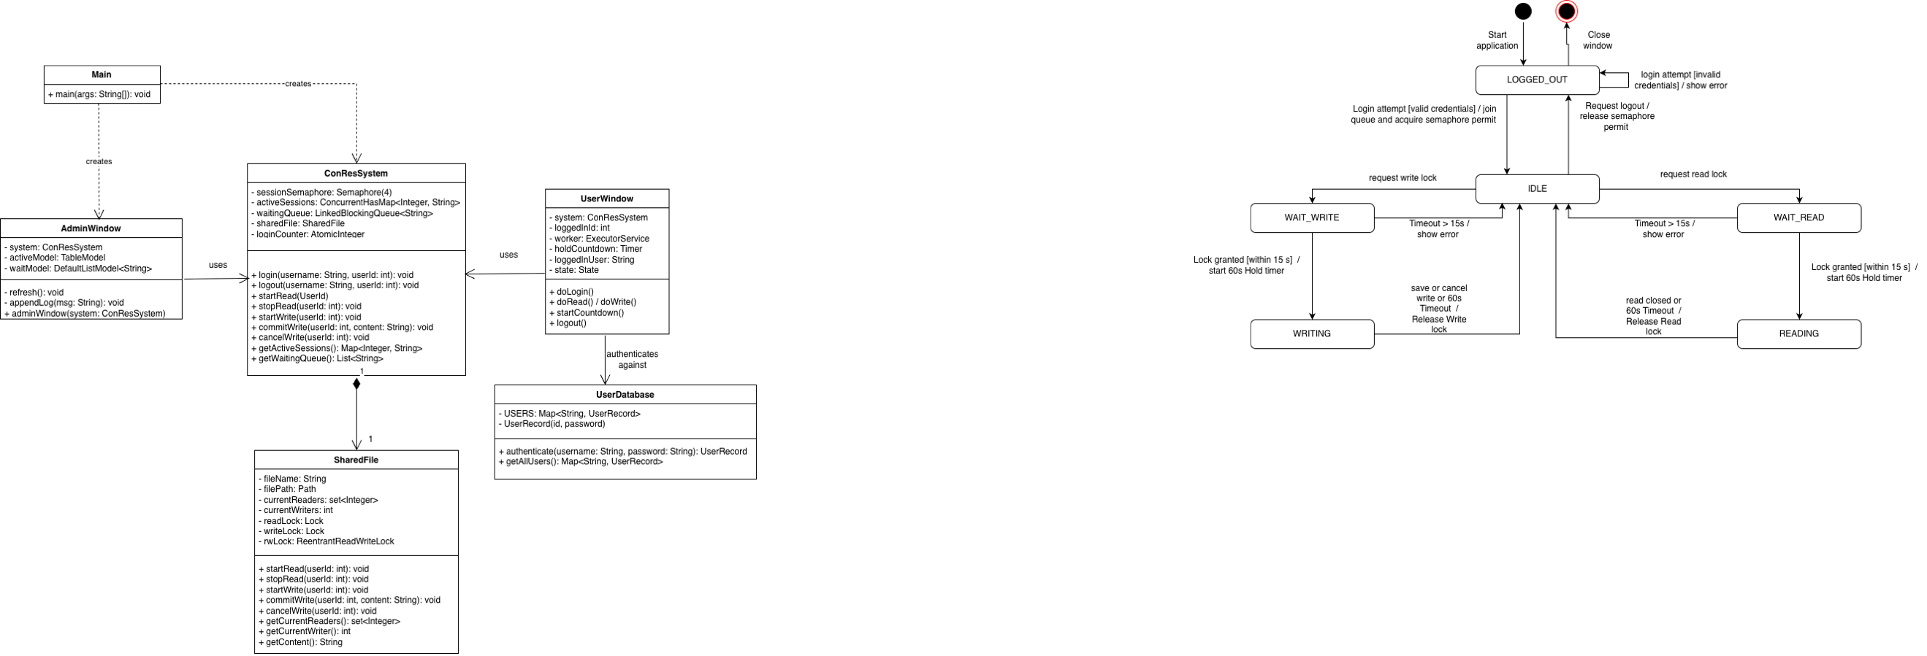
A structural (static) view of the ConRed system architecture represented as the UML Class Diagram:

Figure 1. Structural Diagram ConRes system

ConResSystem is the central controller encapsulating a fair Semaphore for session throttling and a ConcurrentHashMap for thread-safe state tracking. It aggregates SharedFile, which owns the ReentrantReadWriteLock and utilises tryLock() for timeout-based deadlock avoidance. UserWindow implements the per-session state machine on a dedicated worker thread, using volatile flags to handle UI race conditions. Finally, AdminWindow observes state changes via registered Runnable listeners, ensuring the interface remains strictly decoupled from concurrency logic.

Behavioural view
A behavioural (dynamic) view of the ConRes system architecture represented as the UML State Machine diagram:


Figure 2. Behavioural Diagram ConRes system

A thread begins LOGGED_OUT, blocks on semaphore.acquire(), and upon receiving a permit, enters IDLE. Users request shared read locks (READING) or exclusive write locks (WRITING). Both paths utilise tryLock(15s), throwing a LockTimeoutException rather than blocking indefinitely. A 60-second countdown timer runs in the active lock states, triggering automatic release if held too long to prevent starvation. Explicit logouts safely release all permits.

Code and Interface

Code Snippet for Thread Management
// SharedFile.java — tryLock enforces timeout, prevents indefinite blocking
public void startRead(int userId) throws LockTimeoutException, InterruptedException {
boolean acquired = readLock.tryLock(ACQUIRE_TIMEOUT_SECONDS, TimeUnit.SECONDS);
if (!acquired) throw new LockTimeoutException("Read lock not granted within " + ACQUIRE_TIMEOUT_SECONDS + "s");
currentReaders.add(userId); // track for dashboard display
}

public void startWrite(int userId) throws LockTimeoutException, InterruptedException {
boolean acquired = writeLock.tryLock(ACQUIRE_TIMEOUT_SECONDS, TimeUnit.SECONDS);
if (!acquired) throw new LockTimeoutException("Write lock not granted within " + ACQUIRE_TIMEOUT_SECONDS + "s");
currentWriter = userId;
}

Explanation:
SharedFile enforces a multiple-readers/single-writer protocol using a fair ReentrantReadWriteLock to maintain FIFO ordering and prevent starvation. To avoid deadlocks, startRead() and startWrite() utilise tryLock() with a 15-second timeout. If access isn't granted within this window, a LockTimeoutException aborts the request, preventing indefinite blocking.

2.2 Code Snippet for Safe Access to Shared Resources
// ConResSystem.java — semaphore enforces the 4-user session limit
public void login(String username, int userId) throws InterruptedException {
synchronized (this) { // atomic duplicate check
if (activeSessions.containsValue(username) || waitingQueue.contains(username))
throw new IllegalStateException(username + " already logged in");
waitingQueue.offer(username);
}
try {
sessionSemaphore.acquire(); // BLOCKS if 4 users active
} catch (InterruptedException e) {
waitingQueue.remove(username); // clean up queue on window close
Thread.currentThread().interrupt();
throw e;
}
}

Explanation:
ConResSystem throttles concurrent threads using a fair counting Semaphore(4). A synchronised block ensures that checking for duplicate users and inserting them into the waitingQueue occurs atomically. If all four permits are taken, the thread blocks safely on acquire(), enforcing strict FIFO session limits.

2.3 Code Snippet for Data Structure
// ConResSystem.java
private final ConcurrentHashMap<Integer, String> activeSessions = new ConcurrentHashMap<>();
private final LinkedBlockingQueue<String> waitingQueue = new LinkedBlockingQueue<>();
private final AtomicInteger loginCounter = new AtomicInteger(0);

// SharedFile.java
private final Set<Integer> currentReaders = ConcurrentHashMap.newKeySet();
private volatile int currentWriter = -1;

Explanation:
ConcurrentHashMap gives O(1) lock-free reads for active sessions. LinkedBlockingQueue provides thread-safe FIFO ordering for the wait queue. AtomicInteger provides lock-free atomic increments. volatile on currentWriter ensures immediate cross-thread visibility for the single integer writer identifier without synchronisation overhead.

Reflections on Design and Implementation

Knowledge and Skills
- Algorithms & Abstraction (S3, K9): Abstracting the multiple-readers/single-writer protocol into a robust, timeout-based algorithm using ReentrantReadWriteLock. This computational thinking directly translates to Rolls-Royce when analysing Electronic Engine Control (EEC) systems, specifically understanding how signals continuously travel and synchronise between dual operational channels without data collision.
- Technical Reporting & Modelling (S14, K9): Producing this technical design report by modelling system architecture and behaviour via standard UML drawings. This mirrors the rigorous technical documentation and specification processes required for safety-critical aerospace software.
- Configuration Management (S12, K12): Applying strict version control (GitHub) and software build processes to systematically manage the complex, multithreaded codebase. Mastering these configurations and change control tools is essential for maintaining compliant software baselines in Rolls-Royce’s engineering environments.

Challenges and Motivations

- Challenge - Semaphore Leakage: Closing a client window while a user was queued caused the 4-user semaphore limit to break.
Resolution: Caught the InterruptedException during acquire() and utilised a volatile windowClosed flag to safely remove the user from the waitlist without erroneously releasing a permit.
- Challenge - Deadlock Prevention: Implementing robust lock management that simultaneously satisfied consistent lock acquisition order and timeout-based access.
Resolution: Architected the system to strictly acquire the session semaphore before the ReentrantReadWriteLock, while replacing indefinite lock() calls with tryLock(15s) to guarantee thread recovery.
- Motivation - Aerospace Safety: Driven to master these fail-safe concurrency patterns to apply them directly to safety-critical Electronic Engine Control (EEC) systems at Rolls-Royce, where deadlocks cause catastrophic failures.

